

**Advanced Software Engineering**

Course # CSEE 5551 0001

Semester: Spring 2017

LAB Assignment # 6

Submission Date: 3/2/2017

Student Name: Satya Sai Deepthi Katta

Student ID: 16231371

**Instructor:** Dr. Yugyung Lee

**Email:** LeeYu@umkc.edu

**Department of Computer Science & Electrical Engineering**

**University of Missouri, Kansas City**

**Welcome to Lab Assignment #6 Wiki Page!**

Submission on 3/2/17

**TASK 1: Create Cardboard App with an Additional Feature such as Game.**

An Android Game Application which is compatible for the Google Cardboard. This is implemented by using the samples available from the gvk-android-kit. The game basically is the 360 View deployed in Google Cardboard which is similar to Treasure hunt model in the samples.

In this game, the augmented reality is considered like the famous Pokemon Go. The game show cases collecting the cardboard boxes which pops up at random positions which are located in any angle of 360.

Opening the App in the Android phone,

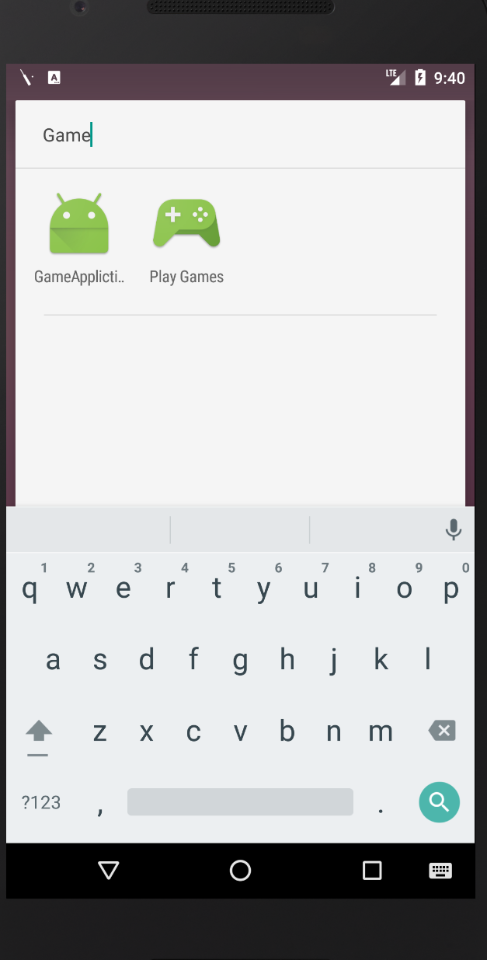

Fig 1. Game Application shown in Android phone.

On launching the application, it shows the message to ‘Place the phone compatible to Cardboard View’.

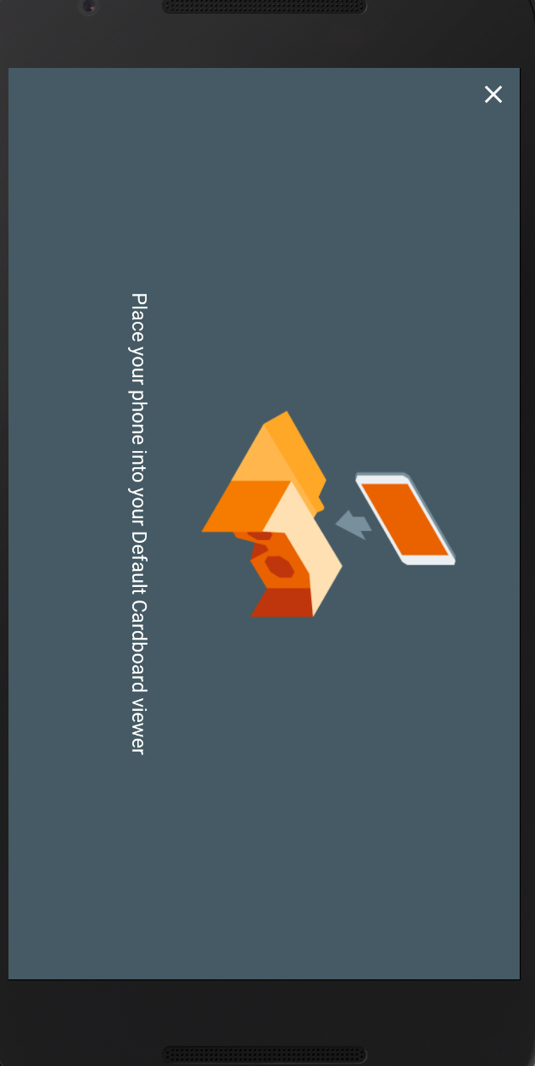

Fig 2. Message popping after launching the Application.

In the settings option provided on the right side navigates to download the cardboard app if not installed in the device.

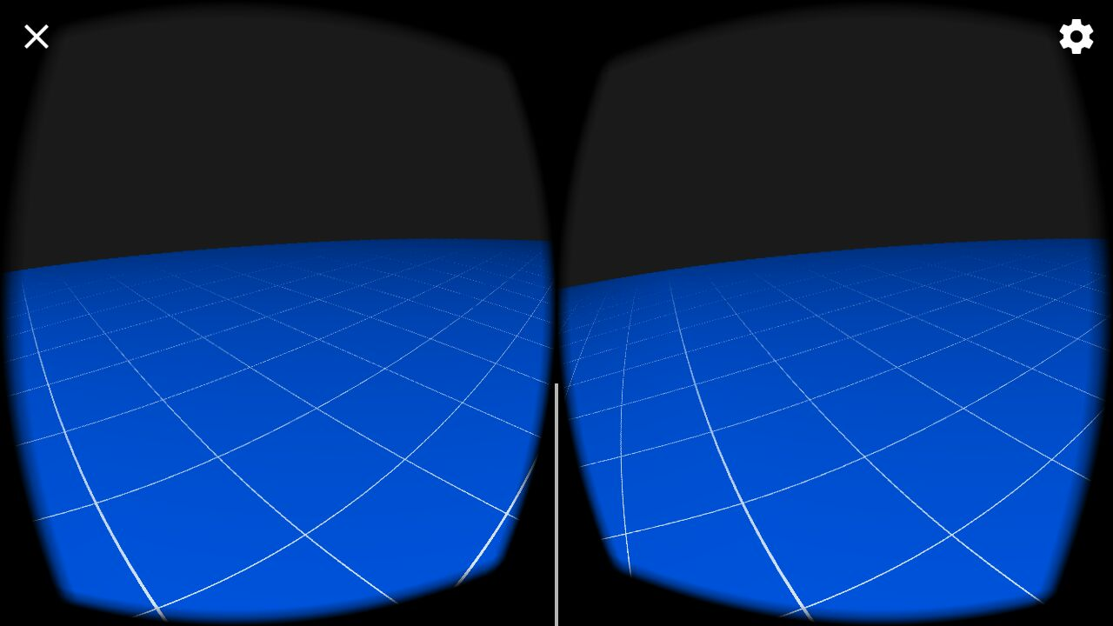

Fig 3. Application background 360 View.

By clicking the ‘X’ Button on the left side corner, the player can exist the game whenever needed.

Below provided are some screenshots for the game.

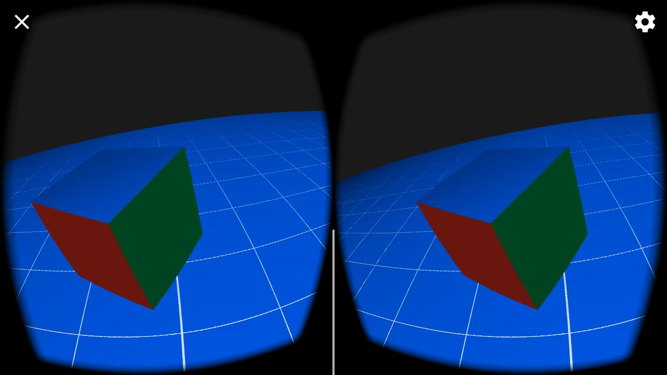

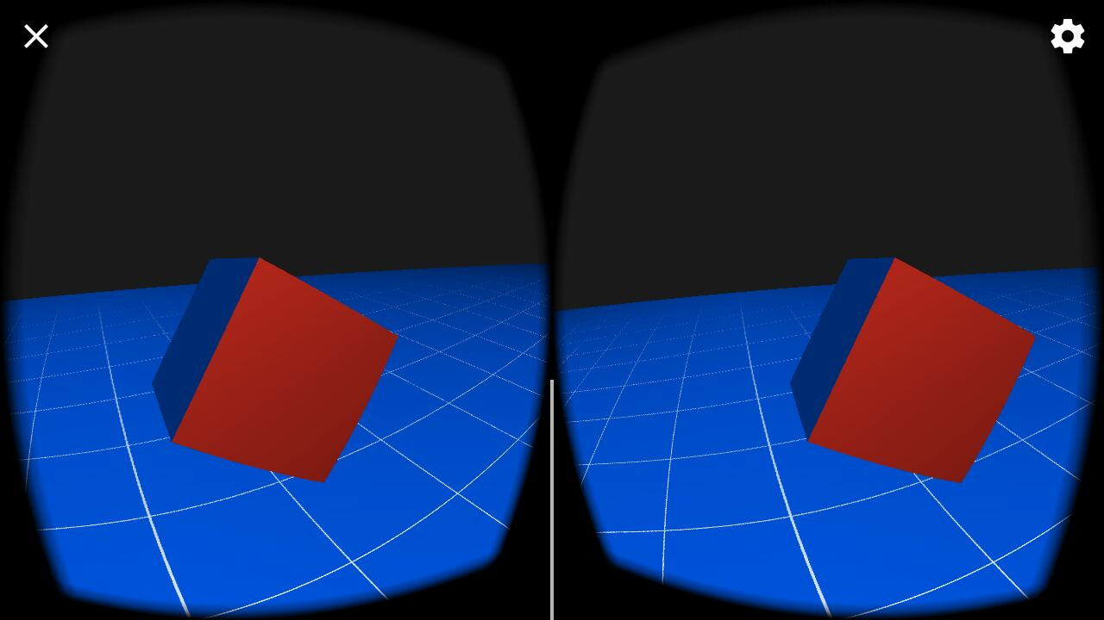

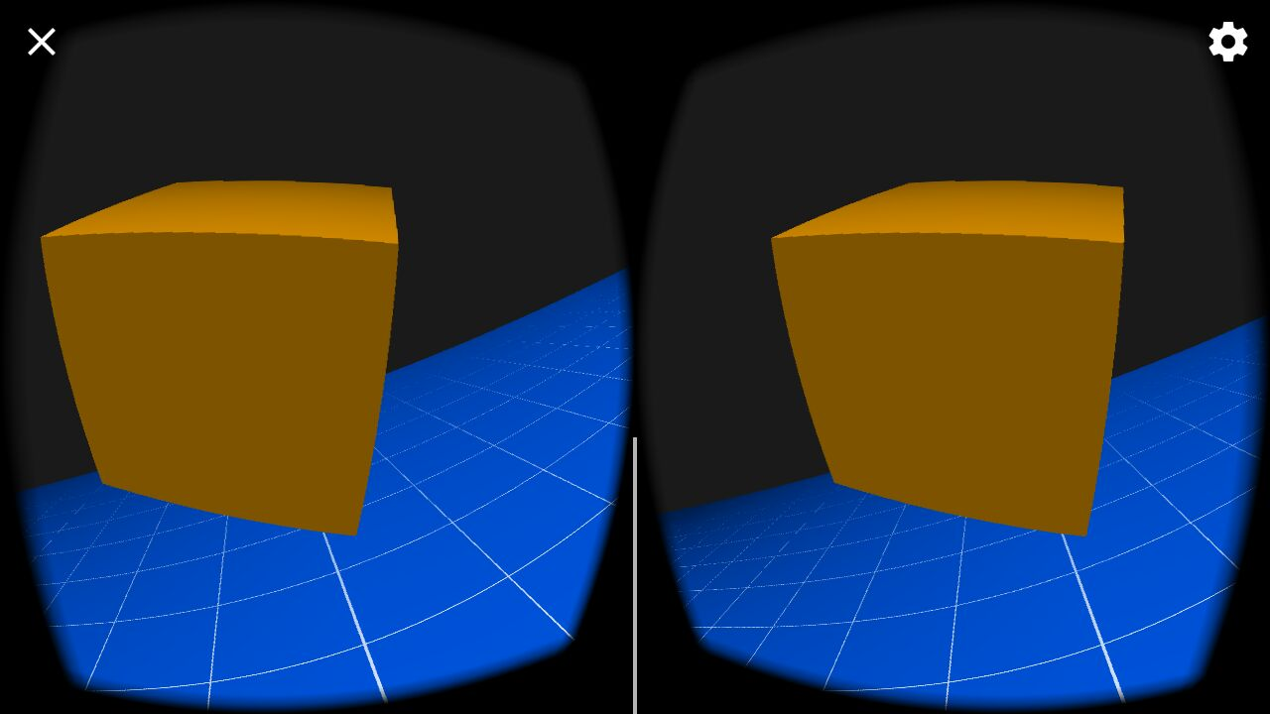

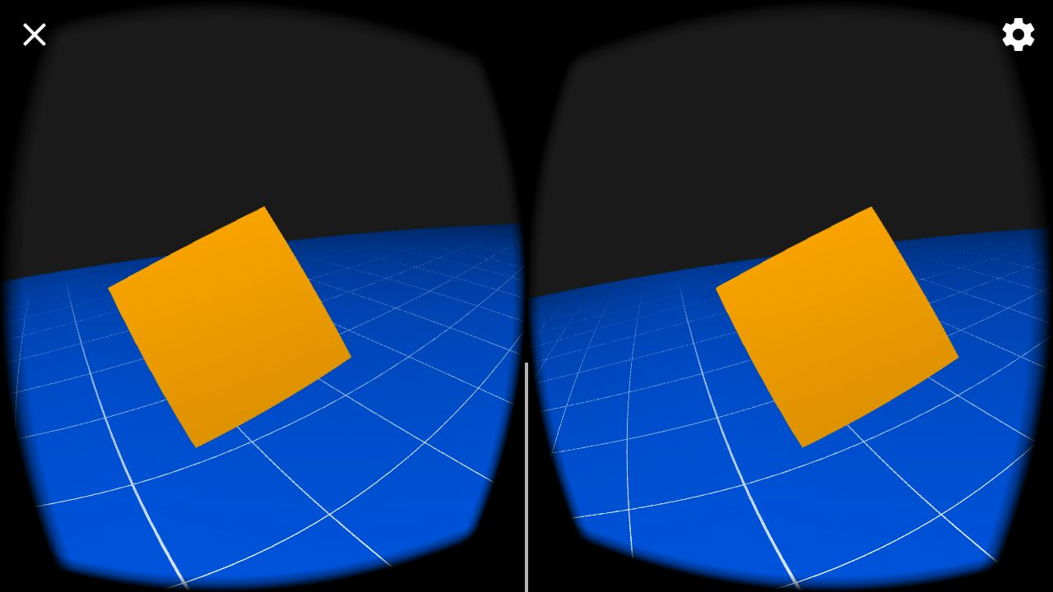



**TASK 2: Create an innovative Application and Deploy it in Smart Watch Emulator.**

A basic application of Flipping a Coin is designed and deployed to the Smart Watch emulator.

The application is created with Flip Coin Application name. The screenshot provided below shows the app displayed among various apps present in the Emulator.

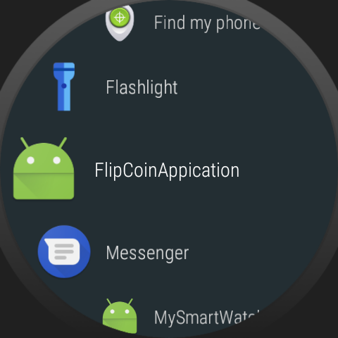

Fig 1. Flip Coin Application in Android Smart Watch Emulator.

After opening the Application a coin is displayed with a ‘Flip Coin’ button on the side.

On clicking the button, the coin is rotated and the result shown is either Heads or Tails. A message is shown either Heads or Tails.

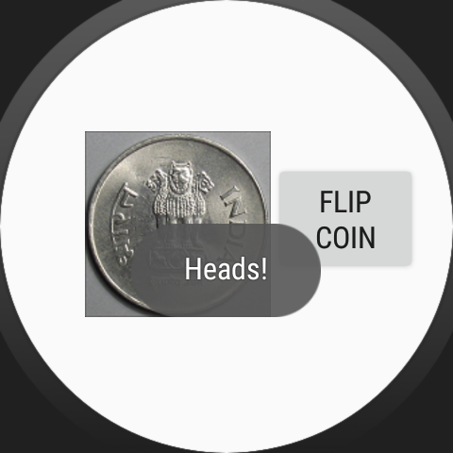

Fig 2. After flipping, the result shown is Heads!

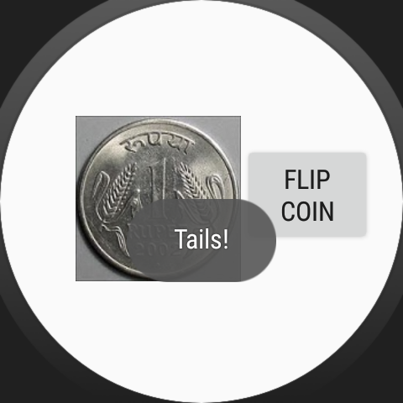

Fig 3. After Flipping, the result shown is Tails!

References:

1. <https://developers.google.com/vr/android/samples/treasure-hunt>